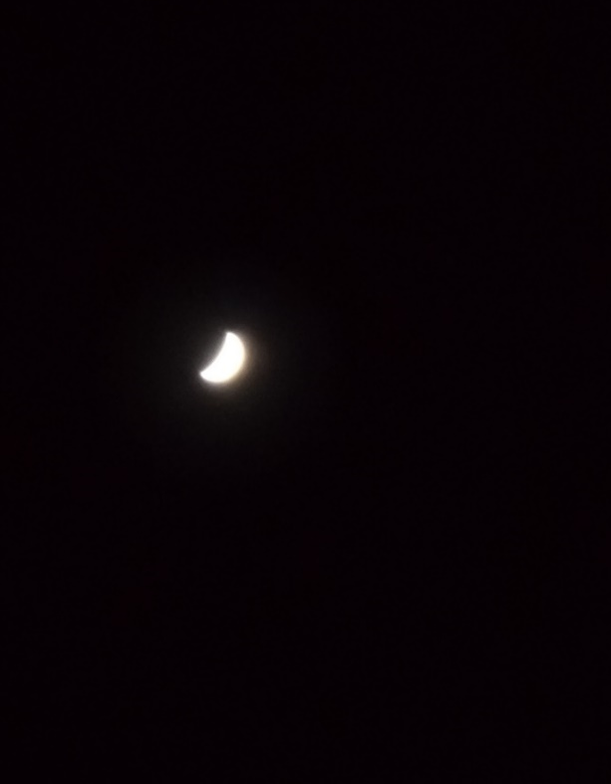
Venera 28 marec 2020 Venera 17 april 2020
Oprema: Celestron SC 9,25 inch f/10+ Oprema: Celestron SC 9,25 inch f/10+
CG-5 GOTO+okular 9 mm+Huawei nova CG-5 GOTO+okular 6 mm+Huawei nova

Venera 27 april 2020
Oprema: Celestron SC 9,25 inch f/10+
CG-5 GOTO+okular 9 mm+Huawei nova

