Venera 28 marec 2020 – Oprema: Celestron SC 9,25 inch f/10+CG-5 GOTO+okular 9 mm+Huawei nova

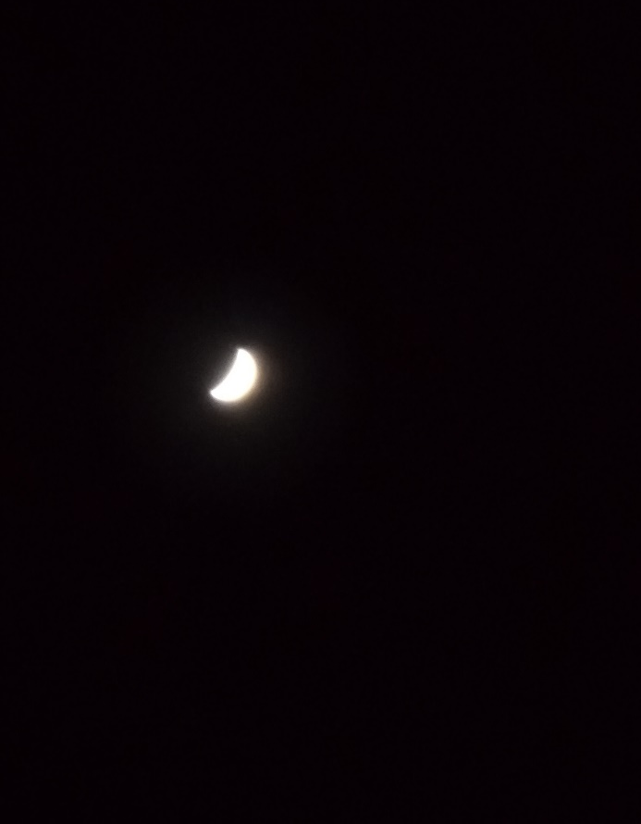
Venera 17 april 2020 – Oprema: Celestron SC 9,25 inch f/10+CG-5 GOTO+okular 6 mm+Huawei nova

