Tuesday, 19th May 2020
ENG8: Workbook exercises

Workbook 125/47:
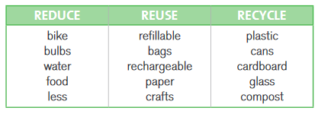
Workbook 125/48:
1 glass 2 cycle path 3 tree 4 ruin 5 consumer 6 walk 7 natural 8 solar power 9 deforestation 10 water pollution
Workbook 126/49:
2 Buy drinks in returnable bottles.
6 Buy products with little packaging.
5 Buy things that will last.
8 Don’t leave them on. This wastes electricity. Switch off lights when not in use.
12 Don’t throw everything away. Reuse old things or donate them.
4 Take showers, not baths. You use less water if you take showers.
7 This wastes water. Don’t let taps drip; turn them off firmly.
9 Turn the water off when brushing your teeth. This saves water.
10 Turn them off when you’re not using them. This saves energy.
1 Use a refillable water bottle.
14 Use energy-saving bulbs.
16 Wait until there are enough clothes to fill the washing machine.
15 Walk, or use a bike, for short trips.
17 You could install a rain barrel and collect rain water for your garden.
11 You should recycle and sort your family rubbish.
3 You should shop with reusable bags.
13 You should use rechargeable ones.

Workbook 127/50:
useful; roots; leaves; cut down; cities; water; branches; names; fires

