Monday, 18th May 2020
ENG7: Will Future – utrjevanje
The joke:
What did a child say? You will go to jail.
What should a child say? You/I will kill a person.
https://www.youtube.com/watch?v=nED_kvrkNNg

Workbook 132/6:
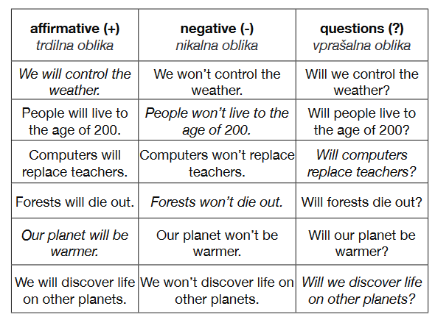
Workbook 133/7:
7a
2. Jane and Jack will get married.
3. Julie will fall ill.
4. Pat will receive a present.
5. Mark will fall in love.
6. Anne will have an accident.
7. Bob will get more pocket money.
8. Kim will be unhappy.
9. Sue and Les will go to a party.
7b
1. Ann won’t go to a party.
2. Pat won’t have an accident.
3. Bob won’t travel by plane.
4. Kim won’t fall in love.
5. Mark won’t be unhappy.
7c
1. Will Jane and Jack get married? – Yes, they will.
2. Will Julie have an accident? – No, she won’t.
3. Will Mark fall in love? – Yes, he will.
4. Will Kim get more pocket money? – No, she won’t.
5. Will Sue and Les go to a party? – Yes, they will.

Workbook 134/9:
2. Why will I/you help him?
3. When will it rain?
4. How old will Bob be next week?
5. What will Slovenia win?
6. What time will Kate be at the party?
7. What will be full?
8. How much will a new car cost?

Workbook 134/10 (možni odgovori):
2. Tom will receive a letter (from abroad). There will be a plane ticket in it. He will fly to America.
3. Mike will meet (lots of) new friends. He will be very popular.
4. Fiona and Jonathan will go skiing. They will have an accident. Fiona will break her arm, and Jonathan will break his leg.
5. Robert and Julie will get married. They will have three children. They will live in a nice house.
6. Sue will pass the test (with grade A). Her parents will be very proud of her.

