UNIT 4 – A MOCK TEST (15th April 2020)
ENGLISH (class 7)
1) Translate the adjective into English and then write its opposite. (Spodnje pridevnike prevedi v angleščino in jim napiši nasprotje.)

 | SLOVENE ADJECTIVE | ENGLISH | OPPOSITE
 | močen
 | umazan
 | težek (v kilogramih)
 | pogumen
___/8
2) Fill in the chart. (Dopolni razpredelnico.)
 | BASE FORM | COMPARATIVE | SUPERLATIVE
 | nice
 | beautiful
 | heavy
 | good
 | bad
___/5
3) Translate the following sentences into English. (Prevedi spodnje povedi tako, da uporabiš primernik ali presežnik.)
a) Kitajska ima več prebivalcev kot Kanada.
__________________ ___________________________________________________
b) Nemški avti so boljši od italijanskih. ______________________________________________________________________
c) Ferrari je hitrejši od Audija. ______________________________________________________________________
d) Triglav je najvišja slovenska gora. ______________________________________________________________________
e) Volga je najdaljša reka v Evropi. ______________________________________________________________________
___/5
4) Read the text and fill in the gaps with the word from the box. the are two words too many. (Preberi spodnje besedilo in ga dopolni z besedo iz okvirčka. Dve besedi sta odveč.)
biggest capital Indians fifty official popular world Spanish people

The USA is the fourth largest country in the (1) ___________________. It is also the richest country.
There are (2)___________________ states in the USA. The 49th is Alaska and the 50th is Hawaii. The (3)___________________ is Washington, D.C. The President of the USA lives and works in the White House.
New York City, with about 7 million (4)___________________, is the largest US city by far. Other big cities are Los Angeles, Chicago, Houston, Philadelphia and Detroit. The most expensive cities are New York and Los Angeles.
The (5)___________________ language in the USA is English, but the second most common language is Spanish.
The most (6)___________________ American sport is baseball. The 4th of July or Independence Day is the most important American holiday. The Americans celebrate the day the US became independent from Britain.
The first people were Native Americans or (7) ___________________. Then came the English, Spanish, Scottish, Irish and other people.
____/7
5) Complete the phrases and then translate them. (Dopolni fraze in jih nato prevedi.)
a) as busy as _____________ - ____________________________
b) as free as ______________ - ____________________________
c) as white as _____________ - ____________________________
d) as green as ____________ - ____________________________
e) as flat as _______________ - ____________________________ ___/5

6) COUNTRIES AND NATIONALITIES. Look at the map and complete the sentences.
(Poglej zemljevid in dopolni povedi – v oklepaju je številka države, iz katere oseba prihaja.)

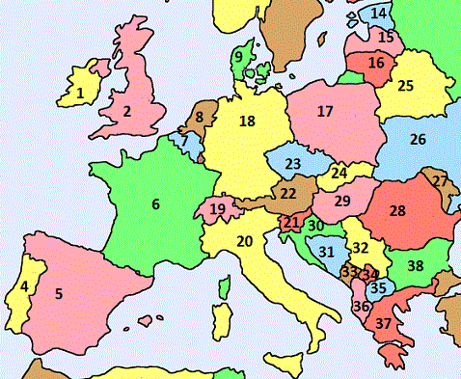
a) (21) Tine is from ______________________.
He is ______________________.
b) (30) Dragana is from ______________________.
She is ______________________.
c) (18) Karl is from ______________________.
He is ______________________.
d) (20) Luigi is from ______________________.
He is ______________________.
e) (37) Electra is from ______________________.
She is ______________________.
___/5

7) Look at the information about New Zealand and write a composition. (Poglej podatke o Novi Zelandiji in napiši sestavek. Podatke iz oklepajev vključi v besedilo.)
država | velikost | glavno mesto | največje mesto | prebivalstvo | najvišja gora | najdaljša reka | živali
Nova Zelandija | prbl. 270.000 km² | Wellington (396.000) | Auckland (1,5 milijona) | 4,5 milijona | Mt. Cook (3.764 m) | Waikato (425 km) | kivi (ptica)

New Zealand covers an area of _____________________________________________________________
___________________________________________________________________________________________________________________________________________________________________________________________________________________________________________________________________________________________________________________________________________________________________________________________________________________________________________________
______________________________________________________________________________________________________________________________________________________________________
___/12

