UNIT 4 – REVISION (14th April 2020)
English (class 7)
1) What's the thing in the picture like? Complete with the appropriate word and then write the opposite, too! (Kakšna je stvar na sliki? Poišči v okvirčku, zapiši, nato pa napiši tudi nasprotje.)

LIGHT EMPTY UGLY TALL LONG HARD-WORKING

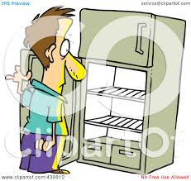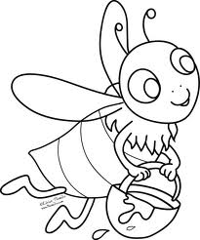
1.__________________ 2.___________________ 3._________________
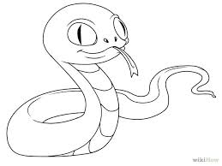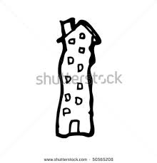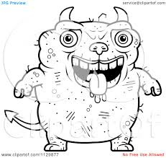
4.__________________ 5.___________________ 6. _________________

2) Insert the correct form of and adjective (comparative or superlative).
(Vstavi pravilno obliko pridevnika (primernik ali presežnik).)
NAMIG:
Če v povedi opaziš besedo THAN, gre za primerjanje in uporabiš primernik (-ER).
Če pred prazno črto opaziš THE, pomeni, da boš moral uporabiti presežnik (-EST). Se še spomniš pravila, da se pred presežniki skoraj vedno pojavi beseda THE?

a) Snow White was _____________________________ (beautiful) than her step mother.
b) Travelling by train is _____________________________ (cheap) than travelling by car.
c) Which is the _____________________________ (popular) language in Europe?
d) Tim's English is _____________________________ (good) than Sally's.
h) Triglav is high, Mont Blanc is _____________________________ (high), but Mount Everest is the _____________________________ (high) mountain of them all.

3) Answer the questions about the USA. (Odgovori na vprašanja o ZDA.)
NASVET: Preden začneš z reševanjem, preberi besedilo na str.105. Lahko tudi poslušaš posnetek tukaj: https://touchstone.si/audio/ts7/105_The_United_States_of_America.mp3

a) How many states has the USA got? __________________________
b) What's the capital of the USA? __________________________
c) Where does the President live and work? __________________________
d) Which is the biggest city in the USA? __________________________
e) Which is the official language? __________________________
f) What happened on the 4th of July? __________________________
g) Which people had to work as slaves in the past? __________________________

4) Great Britain or Canada? Write the correct country on the line next to each statement.
(Velika Britanija ali Kanada? Na črto napiši državo, za katero trditev velja.)
NASVET: Pred reševanjem še enkrat preberi besedilo na str.100. Lahko tudi poslušaš besedilo tukaj: https://touchstone.si/audio/ts7/100_(Great)_Britain_versus_Canada.mp3
- This country is much greener. _______
- The people are quieter. _______
- This country is the second largest country in the world. _______
- The coins are lighter. _______
- The buildings are redder. _______
- The food is better. _______
- The coffee is worse. _______

5) Look at the map of Europe and fill in the blank spots with a country and the language.
(Poglej zemljevid Evrope in dopiši države ter nacionalnosti. Država na zemljevidu ima številko, ki je zapisana v oklepaju pri vsakemu primeru.)
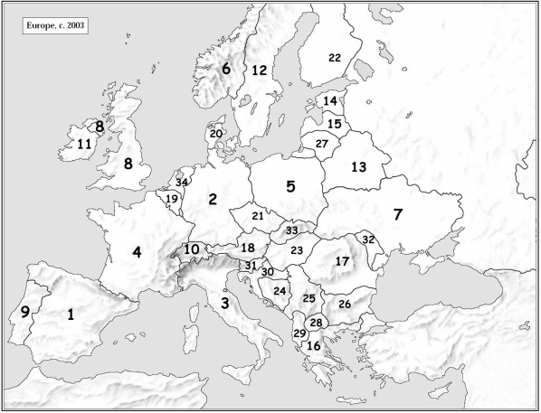

Example: (31) People speak Slovene in Slovenia.
a) (1) People speak _________________________ in _________________________.
b) (2) People speak _________________________ in _________________________.
c) (3) People speak _________________________ in _________________________.
d) (4) People speak _________________________ in _________________________.
e) (8) People speak _________________________ in _________________________.

