Wednesday, 8th April 2020
ENG7: Countries and Nationalities
Book 112/6a:
Matryoshkas-Russia
Vikings-Norway, Sweden, Denmark
the kangaroo-Australia
Lego bricks-Denmark
bullfights-Spain, Portugal
the Eiffel Tower-France
the kozolec-Slovenia
the Beetle-Germany
red double-deckers-Britain
spaghetti-Italy
the Olympic games-Greece
the St. Bernard dog-Switzerland
the sauna-Finland
yodelling / yodellers-Austria
the Atomium-Belgium
wind mills-the Netherlands
the buffalo-the USA
Guinness beer-Ireland
Pippi Longstocking-Sweden
Count Dracula-Romania
Workbook 116/29:
1 Pippi Longstocking – Swedish
2 Martin Krpan – Slovenian
3 Don Quixote and Sancho Panza – Spanish
4 William Tell – Swiss
5 Pinnochio – Italian
6 Count Dracula – Romanian
7 Robin Hood – English
8 Nessie – Scottish
9 Narcissus – Greek
10 Huckleberry Finn – American
Workbook 116/30:
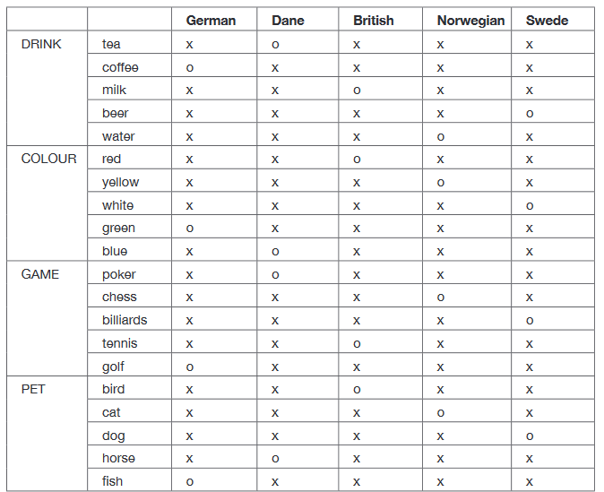

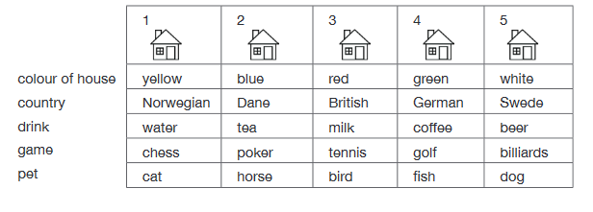
Further explanation:
1.The Norwegian lives in the first house.
2. The Norwegian lives next to the blue house so that means blue is second.
3. You put red in the middle because green has to be to the left of the white house, and the green house man must drink coffee.
4. So the Norwegian lives in the yellow house.
5. The middle house man drinks milk.
6. The yellow house man plays chess.
7. The blue house has a horse because there is no one to the left of the yellow house.
8. The red house owner is Brit.
9. The blue house man must play poker because he has a neighbour who drinks water and there is no other place to have a neighbour that drinks water, so the yellow house man drinks water.
10. The Dane must live in the blue house because he drinks tea and that does not fit in the white house because someone must drink beer and play billiards, so the white house man drinks beer and plays billiards.
11. The German lives in the green house because it says the German plays golf and that does not fit in any other house.
12. The Swede lives in the white house because all the other houses have an owner, and owns a dog as a pet.
13. The Brit must play tennis and own a bird because everyone else plays something else.
14. The yellow house man owns a cat because the one who plays poker lives next to the one who has a cat, and to the right of him there is a bird.
15. So the green house with the German owner who drinks coffee and plays golf has a fish for a pet.
Workbook 117/31:
1. of;
2. on, of;
3. in;
4. about, in;
5. by;
6. from, to;
7. In;
8. with;
9. on;
10. in;
11. on;
12. In;
13. On, from;
14. from, from;
15. of.

