Thursday, 21st May 2020
ENG6: Workbook Exercises

Workbook 134/54:
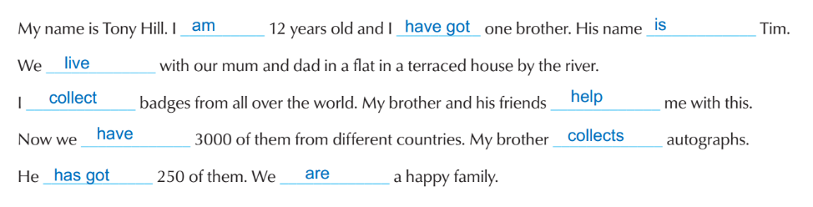
2 Tony has got one brother.
3 They live in a flat in a terraced house.
4 He lives with his mum and dad.
5 He collects badges.
6 His brother collects autographs.
7 He has got 3000 badges.
8 His brother has got 250 autographs.

Workbook 134/55:
1 What’s your favourite sport?
2 What does your brother/ he/ your friend collect?
3 What does your mother/ she/ your sister like doing?
4 Do you like gardening?
5 What is your sister/ she doing now?
6 Have you got a pet?
7 Can it talk?

Workbook 134/56:
1 My sister collects napkins.
2 The Browns are having breakfast now.
3 What sport do you like?
4 My mother cooks very well.
5 Pippi, Tommy and Annika are playing in the hollow tree today.
6 Tim’s dog never sleeps in his bed.
7 We go to bed at ten o’clock.
8 When do you feed your cat?
9 My cat doesn’t like my dog.
10 Roy is playing basketball now. / Roy plays basketball every day.

Workbook 134/57:
