Sreda, 1. 4. 2020
TJA6: The Time Traveller

Knjiga 119/7b: 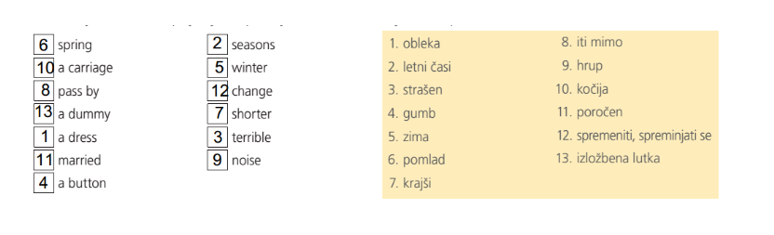
Knjiga 119/7c:
Tukaj so besede, ki si jih moral prebrati namesto sličic v besedilu:
1895: window, trees, street (road/path), dress, first, white (wedding), happy, time machine.
1925: time, horses, house, kitchen, cards, daughter.

Glagoli v Present Continuousu in nedoločniku:
1895: is sitting – sit
is looking – look
are walking – walk
are riding – ride
is passing – pass
is wearing – wear
is kissing – kiss
is pressing – press
is travelling – travel
are changing – change
is changing – change
is getting – get

1925: is happening – happen
aren’t riding – ride
are driving – drive
are making – make
is cooking – cook
is playing – play
is dancing - dance

