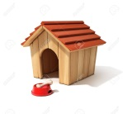
IME: Rocky
STAROST: 3 leta
DOM: pasja uta
HRANA: meso, pasja hrana

A: Have you got a pet?
B: Yes, I have got a dog.
A. What's its name?
B: Its name is Rocky.
A: How old is it?
B: It's 3 years old.
A: What colour is it?
B: It's white.
A: Where does it live?
B: It lives in a kennel.
A: What does it eat?
B: It eats meat and dog food.

