REŠITVE MATEMATIKA 2 20.4. – 24.4.2020
DZ3/10 ZVEZEK
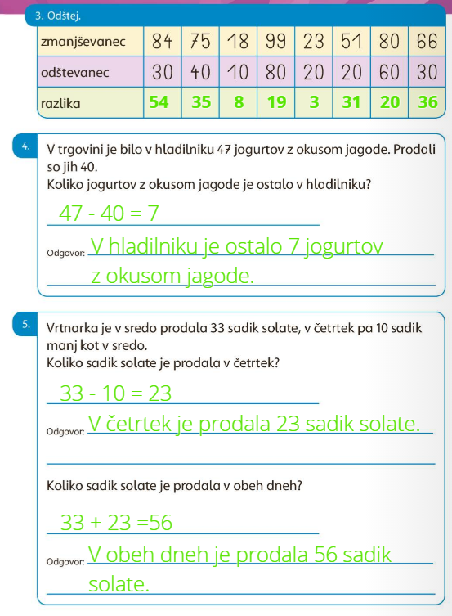
27 – 20 = 7 63 – 0 = 63
52 – 30 = 22 85 – 70 = 15
74 – 50 = 24 49 – 40 = 9
96 – 90 = 6 31 – 10 = 21

