1. V zvezek za angleščino **napiši naslov**: **EXERCISE** (to pomeni vaja).
2. Spodnje **povedi dopolni** z eno izmed besed v rumenem okvirčku.

**ON, IN, UNDER, BY, IN FRONT OF, BEHIND, BETWEEN**

**Povedi prepiši v zvezek in jih glasno preberi.**

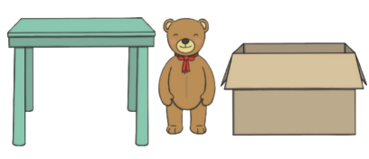

The monster is ____________ the fence.

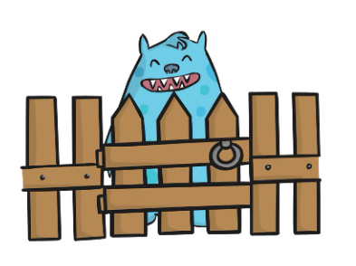

The teddy bear is ____________ the desk and the box.

The cat is ___________ the hat.

The monster is ____________ the cake.

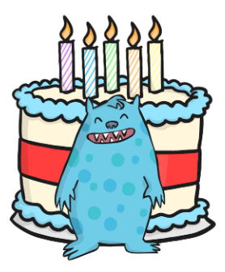



The boy is ____________ the tree.

The cat is ____________ the desk.

The frog is ___________ the leaf.

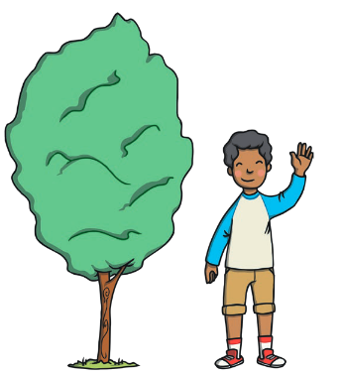

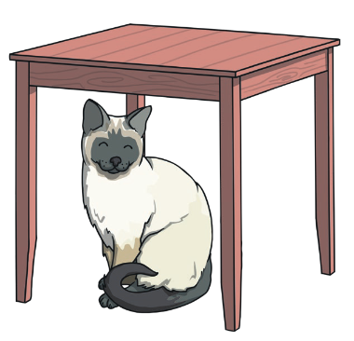

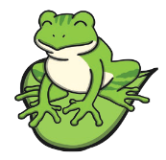

The fox is ___________ the tree.

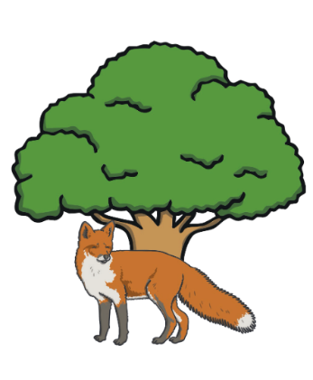

The dog is _____________ the chairs.

