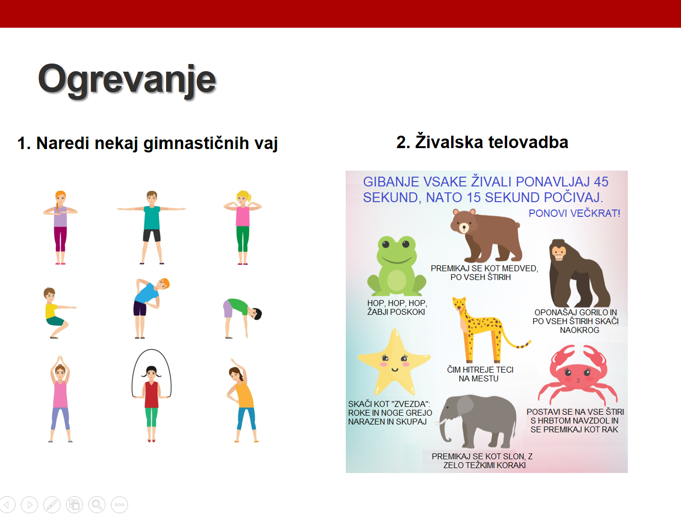
https://www.youtube.com/watch?v=tcpBm571we4&list=PL362rqmZwwAJzj_4jhKIyYCvpUMRotrtl&index=33&t=0s

https://www.youtube.com/watch?v=oY7ZQ9fHSR0&list=PL362rqmZwwAJzj_4jhKIyYCvpUMRotrtl&index=30

https://www.youtube.com/watch?v=6qCbWHQQdR4

