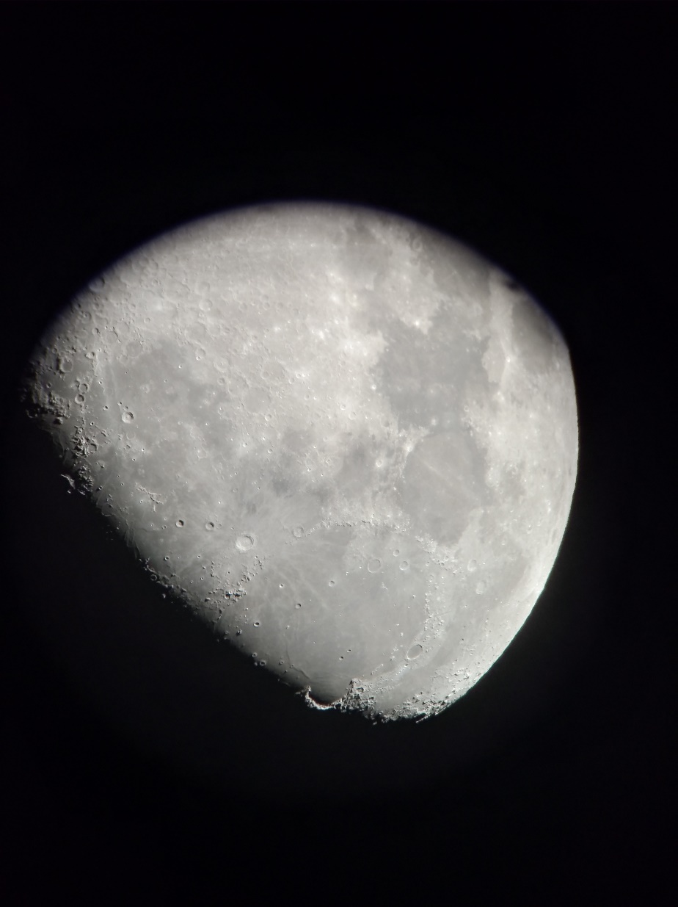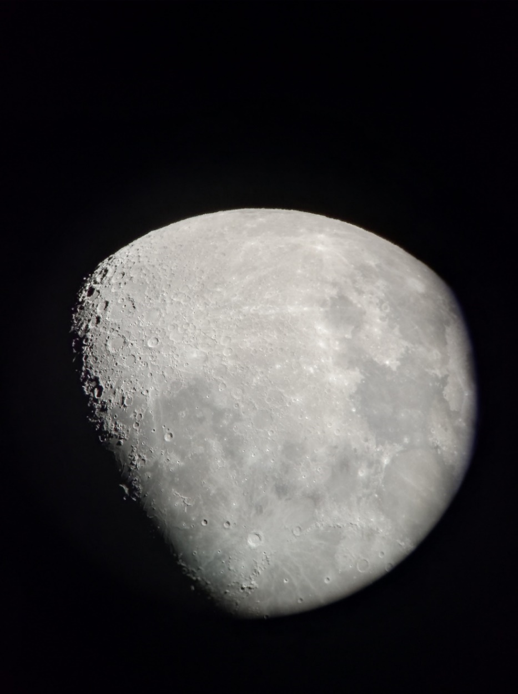
Luna 3. april 2020 – Oprema: Celestron SC 9,25 inch f/10+CG-5 GOTO+okular ?? mm+Huawei nova

