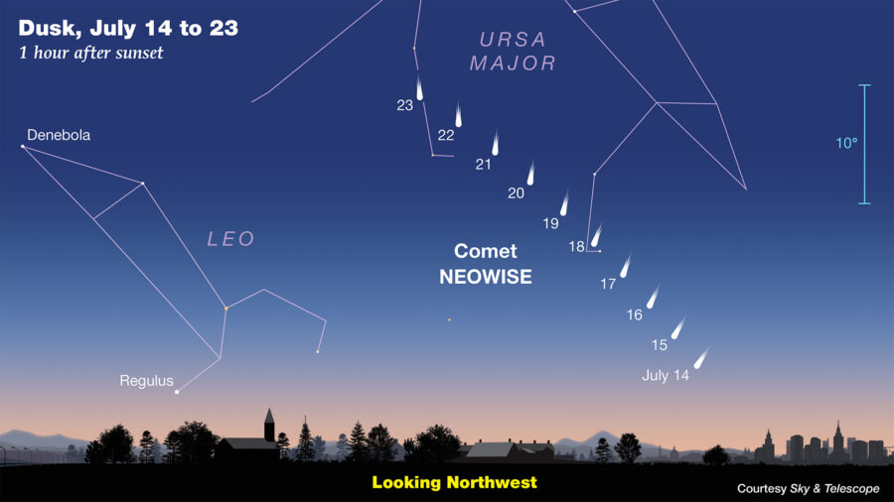
Komet NEOWISE (Vir: https://skyandtelescope.org/astronomy-news/comet-neowise-delights-at-dawn/)

